Name _______________________________________ Date _____________________ Class___________
HOMEWORK: Forms of Energy
For each of the pictures below, determine what form (or forms) of energy are being shown.
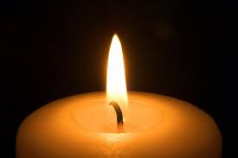

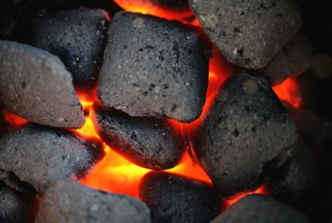

3. CANDLE=
A) ________________________

B) ________________________

2.MAN ON MOUNTAIN= A) ________________________

B) ________________________

1. COAL=
A) ________________________

B) ________________________

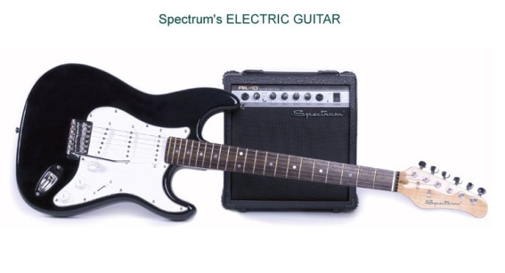

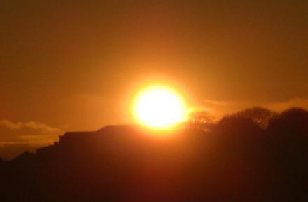

4. GUITAR=
A) _______________________

B) ________________________

6. THE SUN=
A) _______________________

B) ________________________

5. MOUSE ON WHEEL= A) ________________________

B) ________________________

Think about evidence of energy usage in your life each day. Describe the evidence in the left column and what type of energy is being shown in the right column. Follow the example given.

Evidence of Energy being Used | Form of Energy
- Door Closing | Mechanical Energy

